Steel woven wire cloth with square mesh from 4 to 20mm
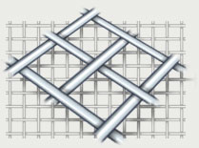 | Plain weave. Width of cloth - 1000, 1300, 1500, 2000 mm. Material - low carbon and stainless steel wire. Wire cloth can be produced with intermediate width and dimensions.

